**Assignment 24.6**

**Problem Statement:**

1. Write a hive query to find the minimum temperature observed in a given weather station in a particular year.

2. Write a hive query to find the maximum temperature observed in a given weather station in a particular year.

3. Write a hive query to find the number of readings given by each weather station according to the dataset.

**Input:**

You can download the dataset from the below link:

<https://drive.google.com/file/d/0Bxr27gVaXO5sTVExTUp5NE9TRXM/view>

**Data Definition:**

Column 1: Weather Station

Column 2: Date (year/Month/Day)

Column 3: Observation Type

Column 4: Temperature

**Output:**

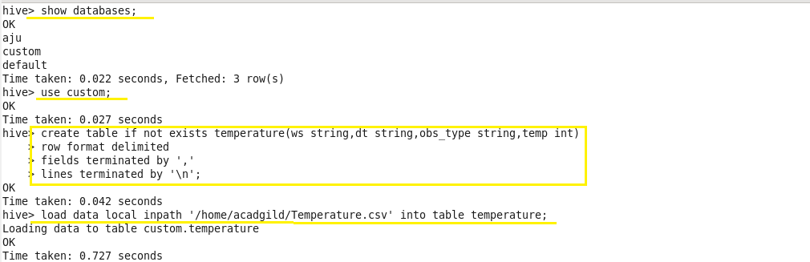

**Problem 1:**

**Write a hive query to find the minimum temperature observed in a given weather station in a particular year.**

**Output:**

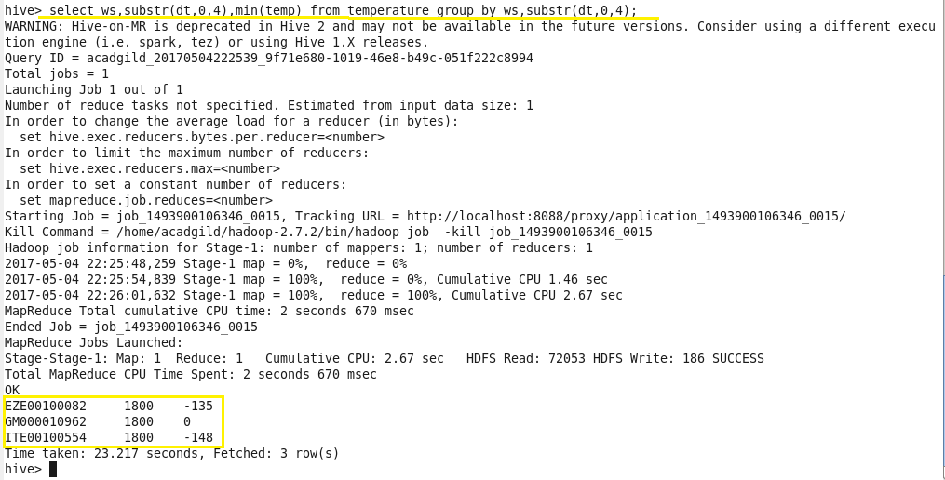

**Problem 2:**

**Write a hive query to find the maximum temperature observed in a given weather station in a particular year.**

**Output:**

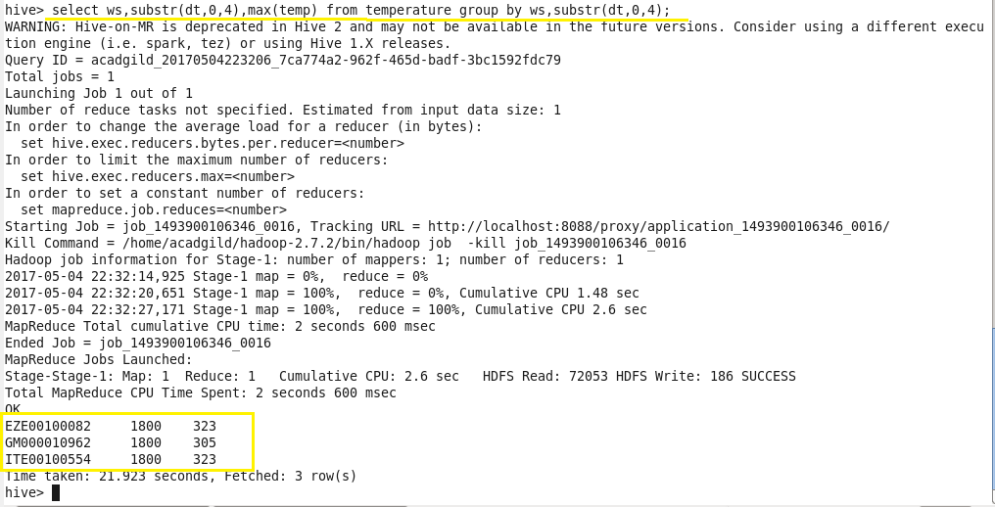

**Problem 3:**

**Write a hive query to find the number of readings given by each weather station according to the dataset.**

**Output:**

